MISS ARSHIA:
Acknowledgment:
- A page of acknowledgements is usually included at the beginning of a Thesis, immediately after the Table of Contents.
- Acknowledgements enable you to thank all those who have helped in carrying out the research.
- The general advice is to express your appreciation in a concise manner and to avoid strong emotive language.
- Note that personal pronouns such as 'I, my, me …' are nearly always used in the acknowledgements while in the rest of the project such personal pronouns are generally avoided.
- What you need is a great list of vocabulary and phrases that you can use so that your Acknowledgements do not sound redundant, boring, or awkward.

Very strong thanks: (save these for the people who helped you the most):
- I would like to express my deepest appreciation to my committee
- I’m deeply indebted to
- I’m extremely grateful to (Something—my success, the completion of my dissertation) would not have been possible without the support and nurturing of (person).

Less strong, but very appreciative:
- I would like to extend my sincere thanks to …/
- I’d also like to extend my gratitude to ….
- Especially/Particularly helpful to me during this time were ____, ___, and ___, who … I also had great pleasure of working with ….

Less strong, but certainly adequate:
- I’d like to acknowledge the assistance/help/effort of….
- I gratefully acknowledge the assistance/help/effort of …
- I’d like to recognize the assistance/help/effort that I received from …..

After you thank, say WHY you are thanking them in the following ways:
- Several people/someone played a decisive role in (doing something for you)
- Someone provided you with encouragement and patience throughout the duration of this project
- Someone never let you down…
- Someone never wavered in their support.

Some adjectives/nouns to describe what these people gave you:
- valuable advice / invaluable contribution / suggestions / experience
- profound belief in my work/in my abilities
- useful/practice/helpful contributions

WAYS TO WHOSE THANKS FIRST THEN OTHER:

- Main supervisor
- Second supervisor
- Other academic staff in your department
- Technical or support staff in your department
- Academic staff from other departments
- Other institutions, organizations or companies
- Past students
- Family *
- Friends *

Conflict of Interest:
- A conflict of interest arises when what is in a person’s best interest is not in the best interest of another person or organization to which that individual owes loyalty.
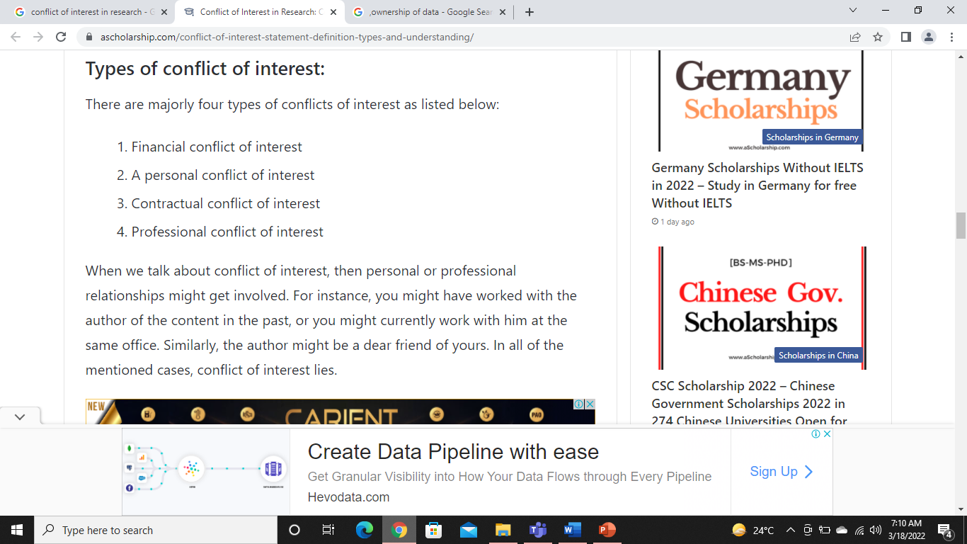
- For example, an employee may simultaneously help himself but hurt his employer by taking a bribe to purchase inferior goods for his company’s use.
- The term “conflict of interest (COI) in research” refers to situations in which financial or other personal considerations may compromise — or have the appearance of compromising — an investigator’s professional judgment in conducting or reporting research.
- Conflicts of interest may be actual, potential or perceived and involve financial and non-financial benefits.
- Conflicts of interest may affect, a researcher's impartiality and judgment, which can erode confidence in the research.

Why Should You Care About Conflicts of Interest?
- Researchers have a tradition of free inquiry and free exchange of ideas, "united in the shared purpose to create knowledge, to critique existing knowledge, and to disseminate knowledge.
- Trust, the core ethical value in this issue, is essential in the scientific pursuit of the truth.
- A relationship based on trust is necessary with colleagues, the government, the study sponsors, and, of course, the public.
- Objectivity is fundamental to this trust.
- Conflicts of interest are intrinsic to the researcher's enterprise. And that is why conflicts of interest are so serious.

Ownership of Data

- Data ownership is the act of having legal rights and complete control over a single piece or set of data elements.
- It defines and provides information about the rightful owner of data assets and the acquisition, use and distribution policy implemented by the data owner.
- Data ownership refers to both the possession of and responsibility for information. Ownership implies power as well as control. The control of information includes not just the ability to access, create, modify, package, derive benefit from, sell or remove data, but also the right to assign these access privileges to others (Loshin, 2002).

Importance of data ownership:

Paradigm of Ownership – Loshin (2002) alludes to the complexity of ownership issues by identifying the range of possible paradigms used to claim data ownership. These claims are based on the type and degree of contribution involved in the research endeavor. Loshin (2002) identifies a list of parties laying a potential claim to data:
- Creator – The party that creates or generate data
- Consumer – The party that uses the data owns the data
- Compiler - This is the entity that selects and compiles information from different information sources

- Enterprise - All data that enters the enterprise or is created within the enterprise is completely owned by the enterprise

- Funder - the user that commissions the data creation claims ownership

- Decoder - In environments where information is “locked” inside particular encoded formats, the party that can unlock the information becomes an owner of that information

- Packager - the party that collects information for a particular use and adds value through formatting the information for a particular market or set of consumers

- Reader as owner - the value of any data that can be read is subsumed by the reader and, therefore, the reader gains value through adding that information to an information repository

- Subject as owner - the subject of the data claims ownership of that data, mostly in reaction to another party claiming ownership of the same data

- Purchaser/Licenser as Owner – the individual or organization that buys or licenses data may stake a claim to ownership

PLAGIARISM
Merriam–Webster dictionary defines plagiarism as
- The theft and use of other people's ideas or words as yours
- Use of sources without attribution
- Literary theft
- presenting some ideas as own and as it is new, while this idea already exists in other source
- Plagiarism is an act of fraud. It involves both stealing someone else’s work and lying about it afterward.
- "Taking over the ideas, methods, or written words of another, without acknowledgment and with the intention that they be taken as the work of the deceiver." American Association of University Professors (September/October,1989)

- But a question arises “can words and ideas really be stolen?”
- According to U.S. law, the answer is yes.

All of the following are considered plagiarism:
- turning in someone else’s work as your own
- copying words or ideas from someone else without giving credit
- failing to put a quotation in quotation marks
- giving incorrect information about the source of a quotation
- changing words but copying the sentence structure of a source without giving credit
- copying so many words or ideas from a source that it makes up the majority of your work, whether you give credit or not (see our section on “fair use” rules)

Types of Plagiarism (The boundary between plagiarism and research is often unclear)

- SOURCES NOT CITED:

The Ghost Writer: The writer turns in another’s work, word-for-word, as his or her own.

The Photocopy: The writer copies significant portions of text straight from a single source, without
alteration.

The Potluck Paper: The writer tries to disguise plagiarism by copying from several different sources, tweaking the sentences to make them fit together while retaining most of the original phrasing.

The Poor Disguise: Although the writer has retained the essential content of the source, he or she has
altered the paper’s appearance slightly by changing key words and phrases.

The Labor of Laziness: The writer takes the time to paraphrase most of the paper from other sources
and make it all fit together, instead of spending the same effort on original work.

The Self-Stealer: The writer “borrows” generously from his or her previous work, violating policies
concerning the expectation of originality adopted by most academic institutions.

- SOURCES CITED;

The Forgotten Footnote: The writer mentions an author’s name for a source, but neglects to include specific information on the location of the material referenced. This often masks other forms of plagiarism by obscuring source locations.

The Misinformed: The writer provides inaccurate information regarding the sources, making it impossible to find them.

The Too-Perfect Paraphrase: The writer properly cites a source, but neglects to put in quotation marks text that has been copied word-for-word, or close to it.

The Resourceful Citer: The writer properly cites all sources, paraphrasing and using quotations appropriately. The catch? The paper contains almost no original work! It is sometimes difficult to spot this form of plagiarism because it looks like any other well-researched document.

The Perfect Crime: Well, we all know it doesn’t exist. In this case, the writer properly quotes and cites sources in some places, but goes on to paraphrase other arguments from those sources without citation

What are copyright laws?
- Copyright laws exist to protect our intellectual property.
- They make it illegal to reproduce someone else’s expression of ideas or information without permission.
- At one time, a work was only protected by copyright if it included a copyright trademark (the © symbol).
- According to laws established in 1989, however, works are now copyright protected with or without the inclusion of this symbol.
- Anyone who reproduces copyrighted material improperly can be prosecuted in a court of law.
- It does not matter if the form or content of the original has been altered – as long as any material can be shown to be substantially similar to the original, it may be considered a violation of the Copyright Act.

Are all published works copyrighted?
- Actually, no.
- The Copyright Act only protects works that express original ideas or information.
- For example, you could borrow liberally from the following without fear of plagiarism:
- Compilations of readily available information, such as the phone book
- Works in the public domain (provided you cite properly)

What is Citation?
A “citation” is the way you tell your readers that certain material in your work came from another source.
It also gives your readers the information necessary to find that source again, including:
- information about the author
- the title of the work
- the name and location of the company that published your copy of the source
- the date your copy was published
- the page numbers of the material you are borrowing

Why should I cite sources?
Giving credit to the original author by citing sources is the only way to use other people’s work without plagiarizing.
But there are a number of other reasons to cite sources:
- Citations are extremely helpful to anyone who wants to find out more about your ideas and where they came from.
- Not all sources are good or right – your own ideas may often be more accurate or interesting than those of your sources. Proper citation will keep you from taking the rap for someone else’s bad ideas.
- Citing sources shows the amount of research you’ve done.
- Citing sources strengthens your work by lending outside support to your ideas.

Quoting Material
- Taking the exact words from an original source is called quoting.
- You should quote material when you believe the way the original author expresses an idea is the most effective means of communicating the point you want to make.
- If you want to borrow an idea from an author, but do not need his or her exact words, you should try paraphrasing instead of quoting.

How Can You Avoid Plagiarism?

Guard yourself against plagiarism, however accidental it may be. Here are some guidelines to avoid plagiarism.

1. Paraphrase your content:
- Do not copy–paste the text verbatim from the reference paper. Instead, restate the idea in your own words.
- Understand the idea(s) of the reference source well in order to paraphrase correctly.
- Examples on good paraphrasing can be found here (https://writing.wisc.edu/Handbook/QPA_paraphrase.html)

2. Use Quotations:
- Use quotes to indicate that the text has been taken from another paper. The quotes should be exactly the way they appear in the paper you take them from.

3. Cite your Sources – Identify what does and does not need to be cited
- The best way to avoid the misconduct of plagiarism is by self-checking your documents using plagiarism checker tools.
- Cite Your Own Material—if you are using content from your previous paper, you must cite yourself. Using material, you have published before without citation is called self-plagiarism.

4. Maintain records of the sources you refer to:
- Maintain records of the sources you refer to. Use citation software like EndNote or Reference Manager to manage the citations used for the paper
- Use multiple references for the background information/literature survey. For example, rather than referencing a review, the individual papers should be referred to and cited.

5. Use plagiarism checkers:
You can use various plagiarism detection tools such as iThenticate or HelioBLAST (formerly eTBLAST) to see how much of your paper is plagiarized.

HOW TO SELECT A JOURNAL FOR RESEARCH PAPER PUBLICATION:
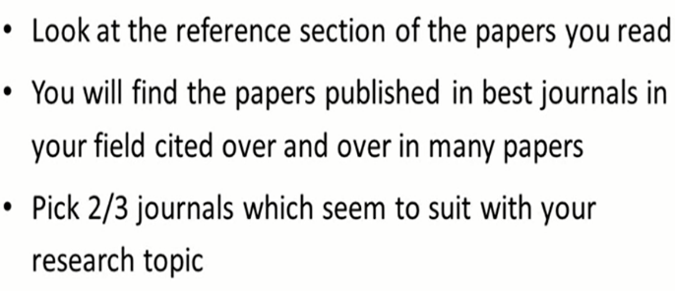
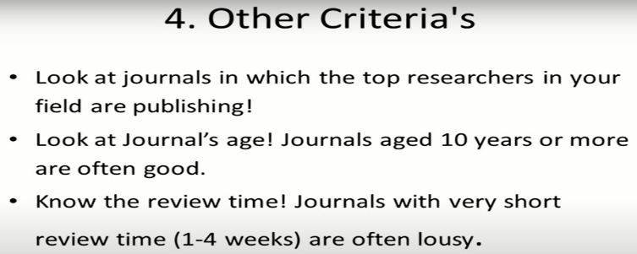

Question: 1 does the aim and scope of the journal match the subject of your article?
- We should check the focus of the journal.
- Check if the journal is Multidisciplinary subject specific.
- Scope of the journal is mentioned on every journal websites.
- We should also check it by viewing Archive of the journal.

Question: 2 Does the journal accept the article type you intended to submit?
- Check the type of the article you intended to submit whether it match the criteria of journal or not.
- We should check whether the journal accept the articles we prepared or not.

Question: 3 what is the target audience? Reader community of the journal?
- We should also focus on the type of Audience while selecting the research journal.
- For the multidisciplinary journal, the reader community is vast.
- However, subject specific journal have limited audience.

Question: 4 Is the journal included in bibliographic and open access database?
- We should check the presence of journal in various indexing libraries for example Google Scholar, index Copernicus etc.
- We should also check if the journal is achieving in open access libraries or subscription libraries.
- Open access libraries have more reader as compared to subscription-based libraries.
- So, it is preferred to publish the article in open access journal.

Question: 5 Does the journal have an online edition?
- Research journals are present in online as well as printed version.
- We should find out whether the journal have online edition or not.
- Online edition provide the opportunity to access the article from around the world.

Question: 6 what is the turnaround time for articles submitted to the journal?
- We should know the total processing time required for the journal to published and process the research article.
- We should know how much time the journal required to review and give suggestion or publish the article when submitted.

Question: 7 how many times in a year is the journal published?
- As the journals are published monthly, bimonthly, quarterly, or half yearly so, we should know how many time in the year the research journal publish its edition or issue.
- We should check the publication frequency of the journal so the publication can be done on time without any break or delay.

Question: 8 what are the articles processing charges?
- Some journal have more publication charges however some have less publication charges. So, we should consider the journal accordingly.

How to write the thesis?

- The purpose of a thesis is to demonstrate your proficiency in academic research and appropriate academic communication, both written and oral.
- When writing your thesis, your information retrieval skills are developed and your facility for critical and analytical thinking, problem solving and argumentation is strengthened.
- Academic writing has its own particular style, with the emphasis on the subject matter along with precision of expression and the use of grammatically correct language.

The Process of writing a Thesis:
Selecting a Topic:
As in all decisions in scientific research, there must be solid arguments concerning the choice of the research topic. There are several aspects worth noting:
- your personal interest in the topic,
- your own resources (knowledge, skills and time available),
- the availability of source material and Data
- the scientific importance of the topic,
- The importance of the topic for your future professional career.

Outlining the general picture:

- What is the state-of-the-art knowledge in the chosen research area?
- Is there much or little earlier research?
- Is it recent or older?
- What kinds of methods and data have been used in earlier research?
- How does your thesis relate to other publications in the field?

Strengthening the substance knowledge:
- Helps you to focus on the essential literature regarding your own thesis.
- Helps you to choose the studies upon which you will develop the theoretical framework of the thesis and design its empirical research setting.

The development of expertise:
- Helps you to evaluate the existing literature critically and to identify potential gaps and shortcomings in it.
- Helps you to make your viewpoint precise and to define the actual research problem or research task.

ORGANISATION OF THE THESIS:

- The general structure of a thesis is always the same, regardless of the research topic or the research orientation.
- A thesis includes the following ingredients in the given order:

Cover page: The title of the thesis should be informative, to the point, and in harmony with the contents of the thesis.
Abstract: The abstract presents its reader with a good general idea of the contents and the most important conclusions of the thesis.

Table of contents: The table of contents has the short title CONTENTS and like all the other main chapter headings and the subheadings along with their page numbers.

Introduction: The introduction normally contains the following issues:
- description, background and significance of the research topic,
- purpose of and motivation for the study,

Data and research method: This section of the thesis includes the description and justification of the data being used (contents, quality, quantity, collection method, adjustments made) and the chosen research method(s).

Data analysis: Data analysis is not a chapter heading, but the most important section of the thesis that contains a detailed description of your own research, the results you have obtained and their interpretation.

Summary:
- The purpose of the thesis and its stated research problem, after which answers will be given to the following kinds of questions:
- What are the main results of the study and what new information has been obtained?
- To what extent can the results be generalized?
- How reliable are the results and what restrictions are there connected with the research?
- How can the results be made use of?

List of references: The list of references contains all the sources cited in the text.

Appendices: The appendices contain all such clarifying information that does not serve any purpose if presented in the actual text.

MISS FARAH JABEEN
Role of Student and Supervisor:

Personal responsibility as a researcher and doctoral candidate:

- Accept responsibility for your eligibility and preparedness for a research degree and for adherence to relevant Faculty and University regulations and guidelines
- Act as a responsible member of the academic community
- Maintain satisfactory progress of the agreed programed of research
- Act in accordance with relevant legislation and regulations in respect of health and safety, ethics etc.
- Ensure that the final thesis is submitted within the designated period, taking due account of advice and recommendations of supervisor(s)

Meetings, written work and records:

- In collaboration with supervisors, set agenda for supervisory meetings and address the schedule of any agreed actions in a timely fashion after each formal meeting.
- Maintain clear, accurate, detailed and accessible records of all relevant work.
- Provide adequate explanation of any failure to meet commitments, including meetings
- Prepare periodic progress reports on the research project by due dates as required by University and Faculty procedures and (where appropriate) any relevant external agencies
- Inform the supervisor of any communications in relation to the research project, including communications from sponsors, external agencies and other researchers

Communication of findings:

- Assume ultimate responsibility for the communication of research findings to others in the academic, scientific and professional communities as appropriate to the area
- Ensure that all contributions to the work are appropriately acknowledged and recognized, paying particular attention to the issue of co-authorship where appropriate
- Obtain appropriate consent from supervisors and any relevant co-authors to publication of findings from work undertaken as part of the thesis
- Avoid inappropriate publication or duplication of others’ work
- Ensure that any circumstances which might require the mode of study to be altered (e.g. transfer to part-time or writing-up status) or the registration period to be extended, suspended or withdrawn, are brought to the attention of his/her supervisor(s)

The Role of the Supervisor N.b. it should be noted that the following guidelines relate to the student’s entire registration period including any period of revision and re-submission:

Personal responsibility as a supervisor and academic:
- Assume, in collaboration with the student, responsibility for the satisfactory progress and completion of the agreed research project, making reasonable adjustments where necessary
- Possess and maintain knowledge of the research area to provide adequate supervision of the research project
- Possess and continue to develop the appropriate skills to facilitate the production of high quality research work by the student
- Develop, in collaboration with the student, an appropriate planning schedule for successive stages of the research project (including writing-up) so that the thesis may be completed and submitted within the appropriate timescale.
- Ensure, where appropriate, that ethical committee and other related approvals have been obtained
Meetings, written work and records:

- Maintain and ensure availability for regular contact with the student, making sufficient time available to fulfil the needs of the individual research student.
- Review written work produced by the student and provide appropriate and constructive criticism in a timely fashion and within two weeks of submission.
- Maintain and ensure that student maintains clear, accurate, detailed and accessible records of work undertaken.
- Maintain and ensure that student maintains a record of supervisory meetings and agreed actions.
- Retain a copy of all written feedback provided to the student.

Communication of finding:
- Encourage students to avail of opportunities to present research work at appropriate seminars and meetings, both intra- and extra-morally.
- Assume an active role in introducing the student to other workers in the field, and in encouraging attendance and membership of appropriate academic bodies and societies.
- Ensure that any formal requirements on the part of external bodies or agencies in relation to the submission of reports, observation of confidentiality, training etc. are met.
- Ensure that appropriate agreement has been obtained with all parties, including external sponsors and potential co-authors, in relation to the communication of research outputs.
- Encourage appropriate and early dissemination of research findings.

Synopsis Writing Steps:

A synopsis is a structured outline of a research thesis and the steps followed to answer the research question. The goal of writing a synopsis is to clearly and thoroughly explain the need to investigate a certain problem using particular practical methods to conduct the study.

Establishing the Background

- A supervisor may ask you to write a synopsis for one or more reasons:
- to help you improve your critical thinking and writing skills
- to help you understand how to design a comprehensive synopsis
- to encourage you to write a comprehensive literature review to make sure that the research problem has not been answered yet
- A synopsis should be coherent in terms of research design. Thus, you should ensure that the research problem, aims, and research methods are logically linked and well-considered.

Note that all synopses should contain answers for several crucial questions:
- Why should research on the proposed problem be undertaken?
- What is expected to be achieved? Important questions:
- What has been done by other researchers on the proposed topic?
- How will the objectives of the study be achieved?

The Writing Process

Before proceeding, consider answering the following questions:
- Why am I going to study this topic?
- Why do I consider it to be important?
- Have I conducted an extensive literature review on the topic?
- What problem will the research help to solve?
- How do I incorporate previous studies on the topic?

The word count should be 2,500–3,000 words. The basic elements of a synopsis include a title page, contents page, an introduction, background, literature review, objectives, methods, experiments and results, conclusions, and references.

Introduction: introduction is written in 1–3 paragraphs and answers the following questions:

- What is the topic of the research?
- What is the research problem that needs to be meaningfully
- Understood or investigated?
- Why is the problem important?
- How will the problem be studied?

Background: In this section, you should set the scene and better introduce the research topic by proving its scientific legitimacy and relevance. Covering the following points in this section:

- Discuss how the research will contribute to the existing scientific knowledge.
- Provide a detailed description of the research problem and purpose of the research.
- Provide a rationale for the study.
- Explain how the research question will be answered.
- Be sure to discuss the methods chosen and anticipated implications of the research.

Literature Review: A review of existing literature is an important part of a synopsis, as it:

- gives a more detailed look at scientific information related to the topic
- familiarizes readers with research conducted by others on a similar subject
- gives insight into the difficulties faced by other researchers
- helps identify variables for the research based on similar studies
- Helps double-check the feasibility of the research problem.

When writing the literature review, do not simply present a list of methods researchers have used and conclusions they have drawn. It is important to compare and contrast different opinions and be unafraid to criticize some of them. Pay attention to controversial issues and divergent approaches used to address similar problems. You may discuss which arguments are more persuasive and which methods and techniques seem to be more valid and reliable. In this section, you are expected not to summarize but analyze the previous research while remembering to link it to your own purpose.

Objectives:
- Identify the objectives of the research based on the literature review. Provide an overall objective related to the scientific contribution of the study to the subject area. Also include a specific objective that can be measured at the end of the research.

Methods:
- When writing this section, consider that the aim of the research is to produce new knowledge regarding the topic chosen. Therefore, the research methodology forms the core of your project, and your goal is to convince readers that the research design and methods chosen will rationally answer the research questions and provide effective tools to interpret the results correctly. It may be appropriate to incorporate some examples from your literature review into the description of the overall research design.

Experiments and Results:
- Logically present and analyze the results of the study using tables or figures.

Conclusion:
- In this section, you should again state the significance of the research and summarize the study. Be sure to mention the study objectives and methods used to answer the research questions. Also, discuss how the results of the study contribute to the current knowledge on the problem.

Summary:
- The purpose of writing a synopsis is to show a supervisor a clear picture of a proposed project and allow him or her to find any gaps that have not been considered previously. A concisely written synopsis will help you gain approval to proceed with the actual research. While no rigid rules for writing this type of paper have been established, a synopsis should be constructed in a manner to help a supervisor understand the proposed research at first glance.

References:
- A synopsis should contain a list of all references used. Make sure the references are formatted according to the chosen citation style and each source presented in this section is mentioned within the body of the synopsis.

Experimental Design:

What is Experimental Research?
- Experimental research is a scientific approach to research, where one or more independent variables are manipulated and applied to one or more dependent variables to measure their effect on the latter. The effect of the independent variables on the dependent variables is usually observed and recorded over some time, to aid researchers in drawing a reasonable conclusion regarding the relationship between these 2 variable types.
- Mostly related to a laboratory test procedure, experimental research designs involve collecting quantitative data and performing statistical analysis on them during research. Therefore, making it an example of quantitative research method.

A Quick Guide to Experimental Design | 5 Steps & Examples:
- Experiments are used to study causal relationships. You manipulate one or more independent variables and measure their effect on one or more dependent variables.
- Experimental design means creating a set of procedures to systematically test a hypothesis. A good experimental design requires a strong understanding of the system you are studying.
- There are five key steps in designing an experiment:
- Consider your variables and how they are related
- Write a specific, testable hypothesis
- Design experimental treatments to manipulate your independent variable
- Assign subjects to groups, either between-subjects or within-subjects
- Plan how you will measure your dependent variable
- For valid conclusions, you also need to select a representative sample and control any extraneous variables that might influence your results. If random assignment of participants to control and treatment groups is impossible, unethical, or highly difficult, consider an observational study instead.

Types of Experimental Research Design

The types of experimental research design are determined by the way the researcher assigns subjects to different conditions and groups. They are of 3 types, namely; pre-experimental, quasi-experimental, and true experimental research.

- Pre-experimental Research Design:
- In pre-experimental research design, either a group or various dependent groups are observed for the effect of the application of an independent variable which is presumed to cause change. It is the simplest form of experimental research design and is treated with no control group.
- The pre-experimental research design is further divided into three types:

- One-shot Case Study Research Design: In this type of experimental study, only one dependent group or variable is considered. The study is carried out after some treatment which was presumed to cause change, making it a posttest study.

- One-group Pretest-posttest Research Design: This research design combines both posttest and pretest study by carrying out a test on a single group before the treatment is administered and after the treatment is administered. With the former being administered at the beginning of treatment and later at the end.

- Static-group Comparison: In a static-group comparison study, 2 or more groups are placed under observation, where only one of the groups is subjected to some treatment while the other groups are held static. All the groups are post-tested, and the observed differences between the groups are assumed to be a result of the treatment.
- Quasi-experimental Research Design:

- The word "quasi" means partial, half, or pseudo. Therefore, the quasi-experimental research bearing a resemblance to the true experimental research, but not the same. In quasi-experiments, the participants are not randomly assigned, and as such, they are used in settings where randomization is difficult or impossible.
- This is very common in educational research, where administrators are unwilling to allow the random selection of students for experimental samples.
- Some examples of quasi-experimental research design include; the time series, no equivalent control group design, and the counterbalanced design.

- True Experimental Research Design:
- A true experiment is a type of experimental design and is thought to be the most accurate type of experimental research.
- True experiment support a hypothesis using statistical analysis.
- A true experiment is also thought to be the only experimental design that can establish cause and effect relationship.

Examples of Experimental Research:

Administering Exams after the End of Semester:
- During the semester, students in a class are lectured on particular courses and an exam is administered at the end of the semester. In this case, the students are the subjects or dependent variables while the lectures are the independent variables treated on the subjects.
- Further making it easy for us to conclude that it is a one-shot case study research.

Employee Skill Evaluation:
- In the course of employment, organizations also carry out employee training to improve employee productivity and generally grow the organization. Further evaluation is carried out at the end of each training to test the impact of the training on employee skills, and test for improvement.
- Here, the subject is the employee, while the treatment is the training conducted. This is a pretest-posttest control group experimental research example.

Evaluation of Teaching Method:
- Let us consider an academic institution that wants to evaluate the teaching method of 2 teachers to determine which is best. Imagine a case whereby the students assigned to each teacher is carefully selected probably due to personal request by parents or due to stubbornness and smartness.
- This is a no equivalent group design example because the samples are not equal. By evaluating the effectiveness of each teacher's teaching method this way, we may conclude after a post-test has been carried out.
- However, this may be influenced by factors like the natural sweetness of a student. For example, a very smart student will grab more easily than his or her peers irrespective of the method of teaching.

